Supplemental Digital Content 1. Equations for calculating numbers need to interview (NNTI) for one STD partner services (PS) recipient to initiate HIV pre-exposure prophylaxis (PrEP)
Method 1 assumes all PrEP initiations following acceptance of a PS-based referral can be attributed to the referral. We calculated the NNTI as the number of HIV-negative men who have sex with men (MSM) interviewed for PS ÷ number initiating PrEP following PS referral weighted by strata:
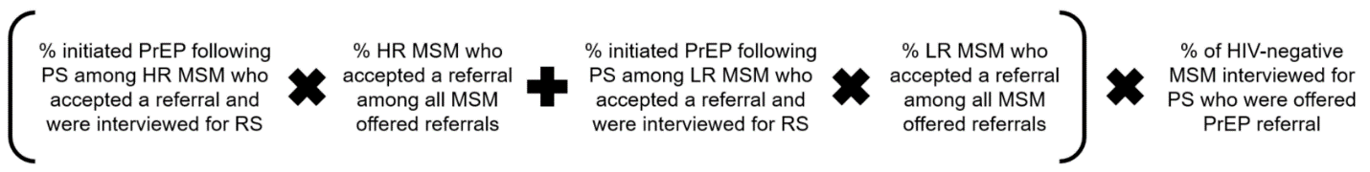
Method 2 assumes the rate of PrEP initiation observed in men who refused referrals represented a background rate that would have occurred in the absence of our intervention. We calculated the NNTI as the number of HIV-negative MSM interviewed for PS ÷ (number initiating PrEP after accepting – refusing PrEP referral) weighted by strata:
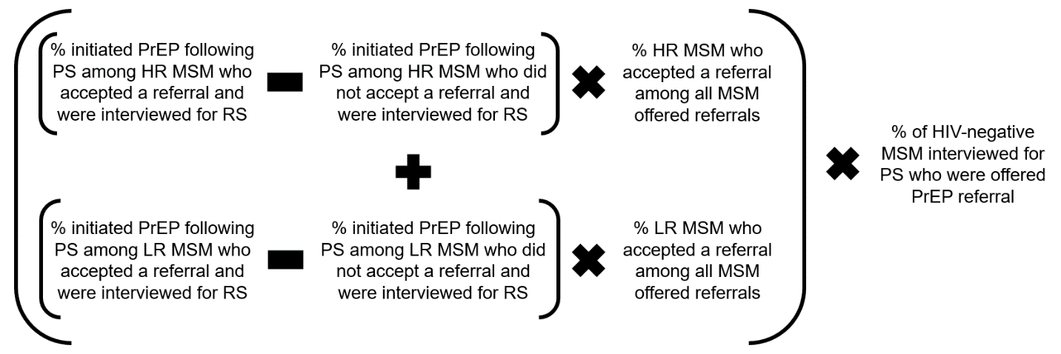
HR = high risk. LR = low risk. RS = random sample.

Supplemental Digital Content 2. Barriers to PrEP use reported by 33 MSM who accepted referrals to PrEP services at an initial STD partner services interview but were not taking PrEP at a follow-up interview
Barrier | Number | Percent
Cost of medications | 2 | 6%
Cost of labs or provider visits | 1 | 3%
Insurance | 6 | 18%
Concern about side effects | 2 | 6%
Does not think he is at risk | 15 | 45%
Stigma or judgment related to PrEP use | 1 | 3%
Taking pills every day | 2 | 6%
Not sure PrEP would prevent HIV | 0 | 0%
Seeing a provider to get medication or for follow-up is too much of a hassle | 14 | 42%
Could not find a provider | 0 | 0%
Could not get an appointment with a provider | 0 | %
Otherª | 3 | 9%
None | 3 | 9%
ªIncludes: Taking medications for other condition and does not want to take more medications; Had PrEP assessment visit but another medical condition arose that delayed PrEP initiation; When used PrEP previously, engaged in riskier behaviors than intended.

