Figure 8. Parallel Growth Model for Effect of PST on Care Recipient Depression via Caregiver Dysfunctional Problem-Solving

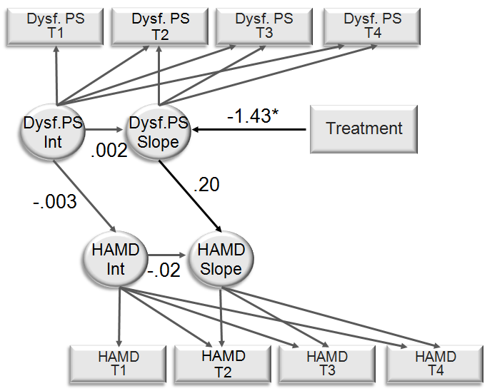

\* *p* < .05

Online Supplemental Material

Previous research suggests that family caregivers of persons with TBI may have a different trajectory of response to PST compared to other caregivers. Rivera et al. (2008) found caregivers receiving PST initially experienced an increase in depression scores, and these steadily declined over time as they benefitted from PST. This kind of “discontinuous” change in response to treatment is familiar in counseling research (Hayes, Laurenceau, Feldman, Strauss, & Cardaciotto, 2007) but it stands in contrast to the “linear” decrease in depression scores experienced by other caregivers (Elliott et al., 2009; Grant et al., 2002; Wade et al., 2006a).

To test potential differences in treatment trajectories of caregiver depression between the TBI subsample and all other disability groups, we used multiple-group analysis implemented in MPLUS. First, the growth model in Figure 2 was estimated simultaneously in both the TBI and non-TBI samples with all parameters in the figure (including mean slopes and intercepts) constrained to be equal. Next, intercepts, slopes, and the treatment effects on slope were freed one at a time, and Satorra-Bentler scaled chi-squared difference tests (on 1 degree of freedom) were calculated to determine whether allowing the groups to differ on each parameter significantly improved model fit. There were no significant differences in the groups on treatment effect (χ2 = .06, *p* = .80) or mean slopes (χ2 = .83, *p* = .36). However, freeing the intercept significantly improved model fit (χ2 = 11.7, *p* < .001). These results indicate that PST produced comparable treatment effects in the TBI and non-TBI samples, even though the TBI caregivers began treatment with higher levels of depression. The final trajectories for the two groups are depicted in Figure 1S.

We used the same multiple-group strategy for comparing trajectories of care recipient depression in the TBI and non-TBI samples. There were no significant differences in treatment effect (χ2 = .08, *p* = .78), intercepts (χ2 = 1.53, *p* = .22), or mean slopes (χ2 = 2.28, *p* = .13). In short, Figure 6 provides a good depiction of treatment trajectories for care recipients in both the TBI and non-TBI samples.

References

Hayes, A. M., Laurenceau, J. P., Feldman G., Strauss, J. & Cardaciotto, L, (2007). Change is not always linear: The study of nonlinear and discontinuous patterns of

change in psychotherapy. *Clinical Psychology Review, 27*, 715-723.

Figure 1S. Trajectories of Caregiver Depression in the Multiple Group Analysis for TBI vs Other Caregivers

