**Supplemental Table 1.** Survival probabilities (%) and hazard ratios at 1 year for children with biventricular or univentricular critical congenital heart defects (CCHDs) enrolled in the National Birth Defects Prevention Study, by clinical and demographic characteristics, 1999-2011

|  |  |  |  |  |  |  |
| --- | --- | --- | --- | --- | --- | --- |
|  | Biventricular CCHD†  N=3346 | | | Univentricular CCHD‡  N=894 | | |
| % (95% CI) | p§ | HR¶ (95% CI) | % (95% CI) | p§ | HR¶ (95% CI) |
| Infant sex |  |  |  |  |  |  |
| Male | 91.4 (90.1-92.5) | 0.06 | 1.00 (Ref) | 69.1 (65.1-72.8) | 0.89 | 1.00 (Ref) |
| Female | 89.4 (87.6-91.0) |  | **1.29 (1.03-1.63)** | 68.7 (63.5-73.4) |  | 0.98 (0.76-1.26) |
| Defect classification |  |  |  |  |  |  |
| Isolated | 93.4 (92.4-94.2) | <0.001 | 1.00 (Ref) | 71.6 (68.3-74.6) | <0.001 | 1.00 (Ref) |
| Multiple/Complex | 75.2 (71.1-78.7) |  | **3.92 (3.10-4.96)** | 50.9 (41.4-59.5) |  | **2.04 (1.52-2.75)** |
| Prenatal CHD diagnosis |  |  |  |  |  |  |
| Yes | 87.9 (84.2-90.7) | 0.02 | 1.00 (Ref) | 67.9 (61.3-73.5) | 0.54 | 1.00 (Ref) |
| No | 91.4 (90.3-92.4) |  | **0.43 (0.31-0.62)** | 69.5 (65.7-72.9) |  | **0.69 (0.50-0.96)** |
| Gestational age at delivery |  |  |  |  |  |  |
| <32 weeks | 63.2 (54.1-71.0) | <0.001 | **6.43 (4.60-8.99)** | 30.8 (14.6-48.5) | <0.001 | **4.00 (2.40-6.67)** |
| 32-36 weeks | 83.9 (80.3-86.8) |  | **2.14 (1.62-2.83)** | 57.1 (47.5-65.7) |  | **1.85 (1.33-2.57)** |
| ≥37 weeks | 93.1 (92.1-94.0) |  | 1.00 (Ref) | 72.0 (68.6-75.0) |  | 1.00 (Ref) |
| Birthweight |  |  |  |  |  |  |
| <1500 grams | 62.5 (53.5-70.2) | <0.001 | **6.21 (4.43-8.71)** | 25.0 (10.2-43.1) | <0.001 | **5.16 (3.08-8.65)** |
| 1500-<2500 grams | 83.4 (79.6-86.6) |  | **2.26 (1.71-2.99)** | 55.9 (46.5-64.3) |  | **1.86 (1.35-2.56)** |
| 2500-<4000 grams | 92.8 (91.8-93.8) |  | 1.00 (Ref) | 72.3 (68.8-75.4) |  | 1.00 (Ref) |
| ≥4000 grams | 95.9 (92.5-97.8) |  | 0.60 (0.32-1.14) | 75.0 (58.5-85.7) |  | 0.83 (0.44-1.58) |
| Small for gestational age |  |  |  |  |  |  |
| Yes | 85.5 (82.3-88.2) | <0.001 | **1.92 (1.47-2.51)** | 59.3 (51.6-66.2) | 0.001 | **1.53 (1.15-2.04)** |
| No | 92.4 (91.3-93.4) |  | 1.00 (Ref) | 72.1 (68.6-75.4) |  | 1.00 (Ref) |
| Plurality |  |  |  |  |  |  |
| Singleton | 91.1 (90.1-92.1) | <0.001 | 1.00 (Ref) | 69.1 (65.9-72.1) | 0.50 | 1.00 (Ref) |
| Multiple | 83.3 (77.4-87.8) |  | **2.23 (1.54-3.22)** | 64.6 (49.4-76.3) |  | 1.29 (0.78-2.13) |
| Season of birth |  |  |  |  |  |  |
| Winter | 90.7 (88.4-92.6) | 0.99 | 1.02 (0.74-1.42) | 69.4 (62.6-75.2) | 0.85 | 1.07 (0.74-1.55) |
| Spring | 90.7 (88.5-92.5) |  | 1.00 (Ref) | 71.4 (64.5-77.1) |  | 1.00 (Ref) |
| Summer | 90.7 (88.7-92.5) |  | 0.92 (0.67-1.27) | 66.7 (60.1-72.4) |  | 1.15 (0.81-1.64) |
| Fall | 90.4 (88.2-92.3) |  | 0.94 (0.68-1.30) | 68.6 (62.6-73.8) |  | 1.08 (0.76-1.53) |
| 1st-degree family history of CHD |  |  |  |  |  |  |
| Yes | 92.7 (86.5-96.2) | 0.40 | 0.86 (0.44-1.68) | 62.2 (44.6-75.6) | 0.38 | 1.30 (0.75-2.25) |
| No | 90.6 (89.5-91.5) |  | 1.00 (Ref) | 69.2 (66.0-72.2) |  | 1.00 (Ref) |
| Time period of birth |  |  |  |  |  |  |
| 1999-2002 | 89.2 (87.2-91.0) | 0.09 | 1.39 (0.99-1.95) | 65.7 (60.2-70.7) | 0.07 | 1.44 (1.00-2.06) |
| 2003-2005 | 92.6 (90.5-94.2) |  | 0.98 (0.67-1.42) | 66.0 (58.9-72.1) |  | 1.34 (0.92-1.97) |
| 2006-2008 | 90.2 (88.0-92.1) |  | 1.24 (0.87-1.76) | 74.3 (67.6-79.7) |  | 0.93 (0.62-1.38) |
| 2009-2011 | 91.0 (88.6-92.9) |  | 1.00 (Ref) | 71.6 (64.5-77.5) |  | 1.00 (Ref) |
| Maternal age |  |  |  |  |  |  |
| <20 years | 87.8 (84.1-90.6) | 0.02 | 0.88 (0.60-1.29) | 65.4 (55.6-73.6) | 0.54 | 0.96 (0.64-1.45) |
| 20-25 years | 89.3 (87.1-91.1) |  | 1.00 (Ref) | 66.5 (60.4-72.0) |  | 1.00 (Ref) |
| 26-35 years | 92.1 (90.7-93.3) |  | 0.81 (0.61-1.07) | 70.4 (66.0-74.4) |  | 0.91 (0.68-1.21) |
| >35 years | 90.6 (87.2-93.2) |  | 1.10 (0.74-1.64) | 72.6 (60.8-81.4) |  | 0.86 (0.52-1.42) |
| Paternal age |  |  |  |  |  |  |
| <20 years | 84.5 (76.5-89.9) | 0.05 | 1.14 (0.65-1.99) | 69.4 (51.7-81.8) | 0.93 | 0.77 (0.39-1.55) |
| 20-25 years | 89.6 (87.1-91.7) |  | 1.00 (Ref) | 68.4 (61.4-74.4) |  | 1.00 (Ref) |
| 26-35 years | 91.6 (90.1-92.8) |  | 0.93 (0.66-1.31) | 68.5 (63.9-72.6) |  | 1.04 (0.72-1.48) |
| >35 years | 91.1 (88.8-92.9) |  | 1.08 (0.68-1.71) | 71.1 (64.0-76.9) |  | 0.98 (0.59-1.61) |
| Maternal race/ethnicity |  |  |  |  |  |  |
| Non-Hispanic White | 92.2 (90.9-93.3) | 0.004 | 1.00 (Ref) | 70.8 (66.4-74.7) | 0.63 | 1.00 (Ref) |
| Non-Hispanic Black | 86.9 (82.9-90.1) |  | 1.31 (0.89-1.92) | 67.5 (58.4-75.0) |  | 1.10 (0.75-1.63) |
| Hispanic | 89.0 (86.8-90.9) |  | 0.95 (0.66-1.36) | 66.4 (60.3-71.8) |  | 1.06 (0.74-1.51) |
| Other | 89.9 (85.4-93.0) |  | 1.23 (0.79-1.91) | 67.9 (53.6-78.7) |  | 1.12 (0.66-1.91) |
| Maternal nativity |  |  |  |  |  |  |
| US-born | 90.7 (89.5-91.8) | 0.49 | 1.00 (Ref) | 69.3 (65.7-72.6) | 0.92 | 1.00 (Ref) |
| Non-US | 91.5 (89.2-93.3) |  | 0.72 (0.51-1.03) | 69.4 (62.2-75.5) |  | 0.93 (0.63-1.36) |
| Maternal primary language |  |  |  |  |  |  |
| English | 91.3 (90.2-92.3) | 0.11 | 1.00 (Ref) | 68.9 (65.2-72.2) | 0.57 | 1.00 (Ref) |
| Non-English | 89.3 (86.8-91.4) |  | 1.00 (0.69-1.44) | 71.0 (63.9-77.0) |  | 0.68 (0.45-1.04) |
| Maternal education |  |  |  |  |  |  |
| <High school | 86.8 (83.7-89.3) | <0.001 | **1.55 (1.11-2.17)** | 64.3 (56.9-70.8) | 0.27 | 1.19 (0.84-1.68) |
| High school | 90.6 (88.4-92.5) |  | 1.06 (0.78-1.44) | 70.7 (64.4-76.2) |  | 0.96 (0.70-1.30) |
| >High school | 92.2 (90.9-93.3) |  | 1.00 (Ref) | 70.6 (66.2-74.5) |  | 1.00 (Ref) |
| Household annual income |  |  |  |  |  |  |
| <$10,000 | 86.8 (83.8-89.3) | <0.001 | **1.81 (1.20-2.75)** | 61.6 (54.0-68.3) | 0.07 | 1.21 (0.78-1.89) |
| $10,000-$50,000 | 90.3 (88.6-91.8) |  | **1.41 (1.02-1.96)** | 69.8 (65.0-74.0) |  | 1.01 (0.72-1.41) |
| >$50,000 | 93.8 (92.3-95.1) |  | 1.00 (Ref) | 72.4 (66.5-77.5) |  | 1.00 (Ref) |
| Number of previous livebirths and stillbirths |  |  |  |  |  |  |
| 0 | 90.2 (88.5-91.7) | 0.50 | 1.12 (0.87-1.44) | 69.7 (64.3-74.4) | 0.77 | 0.98 (0.75-1.29) |
| ≥1 | 90.9 (89.6-92.1) |  | 1.00 (Ref) | 68.6 (64.6-72.3) |  | 1.00 (Ref) |
| Pre-pregnancy BMI |  |  |  |  |  |  |
| Underweight <18.5 | 86.5 (80.0-90.9) | 0.20 | **1.62 (1.01-2.57)** | 70.3 (52.8-82.3) | 0.58 | 1.00 (0.54-1.88) |
| Normal weight 18.5-<25 | 91.4 (89.9-92.7) |  | 1.00 (Ref) | 69.7 (64.9-73.9) |  | 1.00 (Ref) |
| Overweight 25-<30 | 90.5 (88.2-92.4) |  | 1.04 (0.77-1.40) | 70.4 (63.6-76.1) |  | 0.99 (0.73-1.36) |
| Obese ≥30 | 90.4 (88.0-92.4) |  | 1.00 (0.73-1.36) | 64.8 (57.7-71.0) |  | 1.20 (0.88-1.63) |
| Folic acid supplementation†† |  |  |  |  |  |  |
| None | 89.8 (88.2-91.3) | 0.001 | 1.21 (0.86-1.69) | 69.8 (65.1-74.0) | 0.41 | 0.91 (0.66-1.27) |
| <1/day | 89.0 (86.6-90.9) |  | 1.36 (0.96-1.92) | 65.8 (59.4-71.5) |  | 1.10 (0.78-1.54) |
| Daily use | 93.8 (92.1-95.2) |  | 1.00 (Ref) | 71.0 (64.6-76.5) |  | 1.00 (Ref) |
| Pre-existing diabetes |  |  |  |  |  |  |
| Yes | 86.5 (78.3-91.8) | 0.15 | 1.30 (0.74-2.28) | 75.7 (58.5-86.5) | 0.38 | 0.66 (0.32-1.35) |
| No | 90.9 (89.8-91.8) |  | 1.00 (Ref) | 68.7 (65.4-71.7) |  | 1.00 (Ref) |
| Maternal alcohol use‡‡ |  |  |  |  |  |  |
| Yes | 91.1 (89.4-92.6) | 0.67 | 1.15 (0.90-1.47) | 72.4 (67.0-77.0) | 0.15 | 0.92 (0.70-1.21) |
| No | 90.7 (89.3-91.9) |  | 1.00 (Ref) | 67.6 (63.6-71.3) |  | 1.00 (Ref) |
| Maternal smoking‡‡ |  |  |  |  |  |  |
| Yes | 88.8 (86.0-91.1) | 0.05 | 1.29 (0.97-1.71) | 69.1 (61.4-75.5) | 0.90 | 1.04 (0.76-1.44) |
| No | 91.3 (90.1-92.3 |  | 1.00 (Ref) | 69.5 (66.0-72.7) |  | 1.00 (Ref) |
| Folate antagonist medication††§§ |  |  |  |  |  |  |
| Yes | 88.6 (72.4-95.5) | 0.68 | 1.25 (0.47-3.38) | 46.2 (19.2-69.6) | 0.05 | 1.97 (0.92-4.22) |
| No | 90.7 (89.7-91.6) |  | 1.00 (Ref) | 69.2 (66.1-72.2) |  | 1.00 (Ref) |

Abbreviations: BMI, body mass index; CCHD, critical congenital heart defect; CI, confidence interval; CHD, congenital heart defect; HR, hazard ratio; Ref, reference group

NOTE: Cases with more than one CCHD were categorized as biventricular or univentricular based on the defect with highest severity. Pulmonary atresia was not included in biventricular/univentricular groups.

†Includes coarctation of the aorta, dextro-transposition of the great arteries, truncus arteriosus, double outlet right ventricle, Ebstein anomaly, interrupted aortic arch, tetralogy of Fallot, and total anomalous pulmonary venous return

‡Includes hypoplastic left heart syndrome, single ventricle, and tricuspid atresia

§p-value for the log-rank test of trend comparing stratified Kaplan-Meier survival curves

¶Hazard ratio, adjusted for maternal age, maternal race/ethnicity, maternal education, study site, and year of birth; **bold**=95% CI excludes 1.00

††Beginning 1 month prior to pregnancy through the first month of pregnancy

‡‡Beginning 1 month prior to pregnancy through the first trimester

§§Folate antagonist medications included any of the following drug components: tetroxoprim, brodimoprim, pyrimethamine, pyrimethamine bitartrate, pentamidine, pentamidine isethionate, trimethoprim, trimethoprim sulfate, trimethoprim HCL, methotrexate, pemetrexed, pralatrexate, triamterene, sulfasalazine, valproic acid, valproate sodium, divalproex sodium, cholestyramine resin, colestipol HCL, colesevelam, phenobarbital, primidone, phenytoin sodium, phenytoin, carbamazepine, phenobarbital sodium, seromycin, and proguanil HCL

**Supplemental Table 2.** Select clinical and demographic characteristics of interviewed (study-enrolled) and non-interviewed critical congenital heart defects (CCHDs) cases eligible for the National Birth Defects Prevention Study, 1999-2011

|  |  |  |  |  |  |  |
| --- | --- | --- | --- | --- | --- | --- |
|  | Any CCHD | | Biventricular CCHD† | | Univentricular CCHD‡ | |
|  | Interviewed  N (%) | Non-interviewed  N (%) | Interviewed  N (%) | Non-interviewed  N (%) | Interviewed  N (%) | Non-interviewed  N (%) |
| Total | 4380 | 2482 | 3346 | 1876 | 894 | 508 |
| Infant sex |  |  |  |  |  |  |
| Male | 2712 (62.0) | 1478 (59.6) | 2065 (61.8) | 1117 (59.6) | 554 (62.0) | 307 (60.4) |
| Female | 1665 (38.0) | 1003 (40.4) | 1279 (38.3) | 758 (40.4) | 339 (38.0) | 201 (39.6) |
| Gestational age at delivery |  |  |  |  |  |  |
| <32 weeks | 162 (3.7) | 125 (5.2) | 125 (3.7) | 93 (5.1) | 26 (2.9) | 21 (4.2) |
| 32-36 weeks | 620 (14.2) | 436 (18.2) | 483 (14.4) | 342 (18.9) | 112 (12.5) | 71 (14.3) |
| ≥37 weeks | 3597 (82.1) | 1841 (76.6) | 2737 (81.8) | 1374 (76.0) | 756 (84.6) | 404 (81.5) |
| Plurality |  |  |  |  |  |  |
| Singleton | 4108 (94.0) | 2322 (94.1) | 3141 (94.1) | 1750 (93.8) | 845 (94.6) | 483 (96.0) |
| Multiple | 264 (6.0) | 145 (5.9) | 198 (5.9) | 116 (6.2) | 48 (5.4) | 20 (4.0) |
| Season of birth |  |  |  |  |  |  |
| Winter | 1018 (23.2) | 565 (22.8) | 775 (23.2) | 423 (22.6) | 206 (23.0) | 116 (22.8) |
| Spring | 1073 (24.5) | 619 (24.9) | 837 (25.0) | 467 (24.9) | 199 (22.3) | 131 (25.8) |
| Summer | 1170 (26.7) | 634 (25.5) | 908 (27.1) | 480 (25.6) | 228 (25.5) | 130 (25.6) |
| Fall | 1119 (25.6) | 664 (26.8) | 826 (24.7) | 506 (27.0) | 261 (29.2) | 131 (25.8) |
| Time period of birth |  |  |  |  |  |  |
| 1999-2002 | 1400 (32.0) | 550 (22.2) | 1049 (31.4) | 415 (22.1) | 312 (34.9) | 112 (22.1) |
| 2003-2005 | 1039 (23.7) | 563 (22.7) | 807 (24.1) | 423 (22.6) | 197 (22.0) | 111 (21.9) |
| 2006-2008 | 1025 (23.4) | 707 (28.5) | 789 (23.6) | 512 (27.3) | 202 (22.6) | 169 (33.3) |
| 2009-2011 | 916 (20.9) | 662 (26.7) | 701 (21.0) | 526 (28.0) | 183 (20.5) | 116 (22.8) |
| Study site |  |  |  |  |  |  |
| Arkansas | 577 (13.2) | 195 (7.9) | 440 (13.2) | 147 (7.8) | 119 (13.3) | 40 (7.9) |
| California§ | 657 (15.0) | 470 (18.9) | 497 (14.9) | 332 (17.7) | 140 (15.7) | 116 (22.8) |
| Georgia | 630 (14.4) | 333 (13.4) | 476 (14.2) | 257 (13.7) | 132 (14.8) | 59 (11.6) |
| Iowa | 452 (10.3) | 260 (10.5) | 345 (10.3) | 188 (10.0) | 94 (10.5) | 60 (11.8) |
| Massachusetts | 638 (14.6) | 339 (13.7) | 515 (15.4) | 268 (14.3) | 96 (10.7) | 56 (11.0) |
| New York | 418 (9.5) | 309 (12.5) | 323 (9.7) | 248 (13.2) | 82 (9.2) | 52 (10.2) |
| North Carolina | 431 (9.8) | 234 (9.4) | 315 (9.4) | 178 (9.5) | 104 (11.6) | 50 (9.8) |
| Texas | 577 (13.2) | 342 (13.8) | 435 (13.0) | 258 (13.8) | 127 (14.2) | 75 (14.8) |
| Maternal age |  |  |  |  |  |  |
| <20 years | 520 (11.9) | 290 (11.8) | 392 (11.7) | 198 (10.7) | 107 (12.0) | 81 (16.1) |
| 20-25 years | 1204 (27.5) | 756 (30.8) | 917 (27.4) | 560 (30.2) | 254 (28.4) | 164 (32.6) |
| 26-35 years | 2193 (50.1) | 1120 (45.6) | 1664 (49.7) | 863 (46.5) | 460 (51.5) | 207 (41.2) |
| >35 years | 463 (10.6) | 290 (11.8) | 373 (11.2) | 235 (12.7) | 73 (8.2) | 51 (10.1) |
| Maternal race/ethnicity |  |  |  |  |  |  |
| Non-Hispanic White | 2406 (54.9) | 1121 (46.2) | 1871 (55.9) | 858 (46.8) | 456 (51.3) | 226 (45.4) |
| Non-Hispanic Black | 476 (10.9) | 366 (15.1) | 337 (10.1) | 268 (14.6) | 123 (13.8) | 81 (16.3) |
| Hispanic | 1186 (27.1) | 750 (30.9) | 891 (26.6) | 560 (30.5) | 259 (29.0) | 161 (32.3) |
| Other | 312 (7.1) | 192 (7.9) | 247 (7.4) | 149 (8.1) | 53 (5.9) | 30 (6.0) |

Abbreviations: CCHD, critical congenital heart defect

NOTE: Cases with more than one CCHD were categorized as biventricular or univentricular based on the defect with highest severity. Pulmonary atresia in the absence of other CCHDs (N=140 interviewed and N=98 non-interviewed cases) was not included in biventricular/univentricular groups.

†Includes coarctation of the aorta, dextro-transposition of the great arteries, truncus arteriosus, double outlet right ventricle, Ebstein anomaly, interrupted aortic arch, tetralogy of Fallot, and total anomalous pulmonary venous return

‡Includes hypoplastic left heart syndrome, single ventricle, and tricuspid atresia

§Mortality data for California were only available up to 1 year of age

**Supplemental Figure 1.** Survival at age 1 for interviewed (study-enrolled) and non-interviewed critical congenital heart defect (CCHD) cases eligible for the National Birth Defects Prevention Study (1999-2011), for a) biventricular CCHD; and b) univentricular CCHD

a) b)

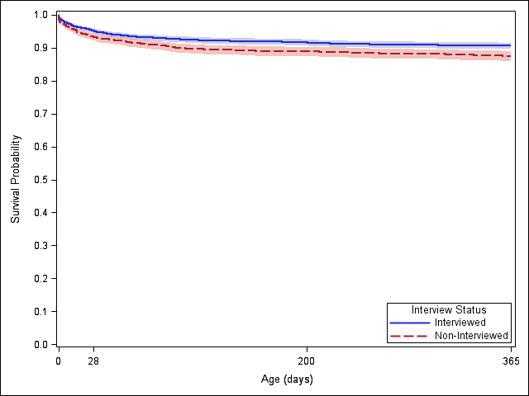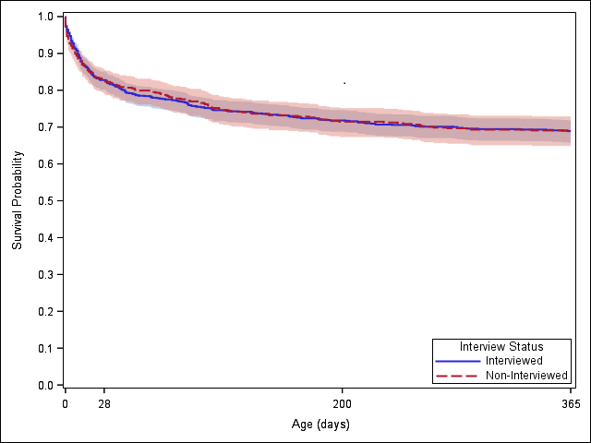

p=0.009 (log-rank test) p=0.96 (log-rank test)

**Figure Legend**

Interview Status

Interviewed

Non-Interviewed

NOTE: Cases with more than one CCHD were categorized as biventricular or univentricular based on the defect with highest severity. Pulmonary atresia was not included in biventricular/univentricular groups.

**Supplemental Figure 2.** Survival in early childhood for interviewed (study-enrolled) and non-interviewed critical congenital heart defect (CCHD) cases eligible for the National Birth Defects Prevention Study (1999-2011), for a) biventricular CCHD; and b) univentricular CCHD

a) b)

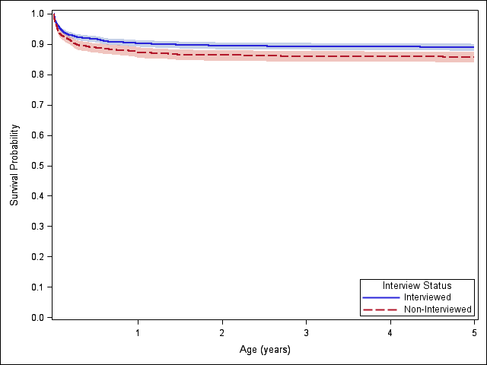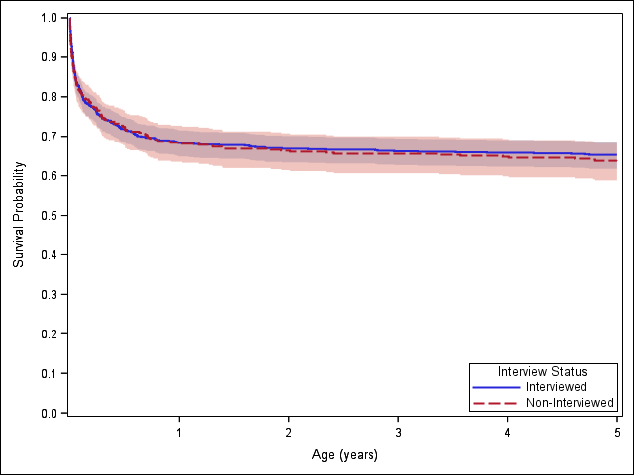  
p=0.002 (log-rank test) p=0.65 (log-rank test)

**Figure Legend**

Interview Status

Interviewed

Non-Interviewed

NOTES: Cases with more than one CCHD were categorized as biventricular or univentricular based on the defect with highest severity. Pulmonary atresia was not included in biventricular/univentricular groups. Excludes California.