**Supplementary Figure. Study flow diagram of patients meeting selection criteria (see ppt file for source).**

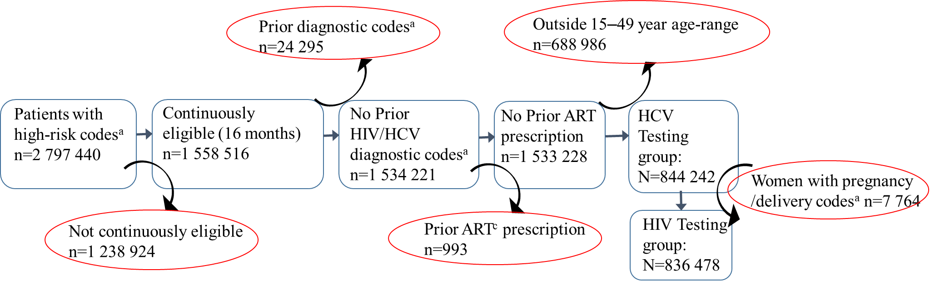

Source: IBM Watson Health MarketScan® (IBM, Incorporated, Armonk, New York) Commercial Claims and Encounters database, 2003–2017.

a Diagnosis codes were based on the *International Classification of Diseases, Ninth Revision or Tenth Revision, Clinical Modifications,* (ICD-9-CM, ICD-10-CM) billing claim codes.

b ART, antiretroviral therapy, medication used for treatment of HIV infection.

**Supplementary Table 1. ICD9a-ICD10b Codes Related to Illicit Drug Use Risk Behavior, Categorized Into 4 Presentation Groups of Persons at High Risk**

Substance use or dependence group — ICD-9-CMa or ICD-10-CMb codes identifying persons with diagnosed nonmedical drug use or dependence. Patient identification was based on a single occurrence of injection drug-related codes for the medical visit, whether inpatient or outpatient.

|  |  |  |
| --- | --- | --- |
| **Type** | ICD-9-CMa | ICD-10-CMb |
| Opioid | 304.0, 304.7, 305.5 | F11 |
| Cocaine | 304.2, 305.6, 9701 | F14, T405, R782 |
| Amphetamine | 304.4, 305.4, 305.7 | F15 |
| Sedative | 304.1, 305.1, | F13, T423-T428 |
| Other | 304.5, 304.6, 304.8-304.9, 305.9 | T42, T436-T439 |
| Overdose group — ICD-9a or ICD-10b codes identifying persons diagnosed with poisoning by drugs, overdose of drugs or suicide attempt with drugs. | | |
| **Type** | ICD-9-CMa | ICD-10-CMb |
| Opioid | 9650, 9701, 97081, E8500-E8502, E950, E9352 | T400- T404, T406 |
| Cocaine | 9708 | T405, T4069 |
| Amphetamine | 9697 | T4360, T4362, T4369 |
| Sedative | 9694, E8532 | F13, T423-T424 |
| Other |  | T4060 |
| Medication-assisted therapy group — CPT codes identifying persons who received medication for opioid addiction or overdose. | | |
| CPTc | H0020, J2310¸ J2315 | |
| Skin or soft-tissue infection or endocarditis group — ICD-9-CM or ICD-10-CM codes identifying persons with injection-related infections (eg, skin and soft-tissue infections, including limb abscess or cellulitis, acute osteomyelitis, or ventricular endocarditis). | | |
| **Type** | ICD-9-CMa | ICD-10-CMb |
| Endocarditis | 421 | I330, I339, I39, B376, I38, |
| Soft-tissue infection | 68100-68102, 68110,68111, 6819, 6820-6829, 11281, 397, 41512, 11281, 3970, 71100-71109, 72886, 73000-73009, | L020, L02211-L02219, L0231, L0233, L02411- L02419, L02511, L02512, L02619, L028, L0291, L0311- L0319, L03121-L03129, E920.5, B37.6, I26.01, I26.90, M00.00, M00.01, M00.09, M00.21, M00.29, M00.81, M00.89, M86.11, M86.19, W46.0, W46.1 |

a,b Diagnosis codes were based on the *International Classification of Diseases, Ninth Revision or Tenth Revision, Clinical Modifications,* (ICD-9-CM, ICD-10-CM) billing claim codes.

c Diagnosis codes based on Current Procedural Terminology (CPT).

**Supplementary Table 2. ICD-9-CM** a **ICD-10-CM**b **for HIV or Hepatitis C Virus Infection Diagnosis**

|  |  |  |
| --- | --- | --- |
| **Infection** | ICD-9-CM a | ICD-10-CM b |
| HIV | 042, 795.3, 795.71, V08 | B20, B9735, R75, Z21, O987 |
| Hepatitis C | 070.41, 070.44, 070.51, 070.54, 070.70, 070.71 | B1711, B182, B1710, B182, B1920, B1921 |

a,b Diagnosis codes were based on the *International Classification of Diseases, Ninth Revision or Tenth Revision, Clinical Modifications,* (ICD-9-CM, ICD-10-CM) billing claim codes.

**Supplementary Table 3. *Current Procedural Terminology* (CPT)**c **Codes for HIV or Hepatitis C Virus Testing**

|  |  |
| --- | --- |
| **Infection** | CPTc |
| HIV | G0432, G0433, G0435, 86689, 8670, 87389, 87534-87391, 87901 |
| Hepatitis C | G0472, 80074, 86803, 86804, 87520-87522, 87902, 3266F |

c Diagnosis codes based on Current Procedural Terminology (CPT).

**Supplementary Table 4. ICD-9-CM** a**, ICD-10-CM** b **and CPT**c **Codes for Pregnancy and Delivery**

|  |  |  |
| --- | --- | --- |
| CPTc | ICD-9-CM a | ICD-10-CM b |
| 59400,59409, 59410, 59510-59515, 59610-59622 72, 73, 74, 75 | 630-639, 640x-648x, 651x-659x, 6560x-6569x, 670x- 679x, 640x-648x (where x ends =1 or 2) 7680, 7681, V274, V278, V27, V30-V39 | O80-O84,O68, O70-O77,O24,O43-O45, P95   Z37, Z38, O394 O364, O998, O365, O366 |

a,b Diagnosis codes were based on the *International Classification of Diseases, Ninth Revision or Tenth Revision, Clinical Modifications,* (ICD-9-CM, ICD-10-CM) billing claim codes.

c Diagnosis codes based on Current Procedural Terminology (CPT).