Supplemental Figure 1. Directed Acyclic Graph for covariate selection between drinking water disinfection byproducts and congenital heart defects.
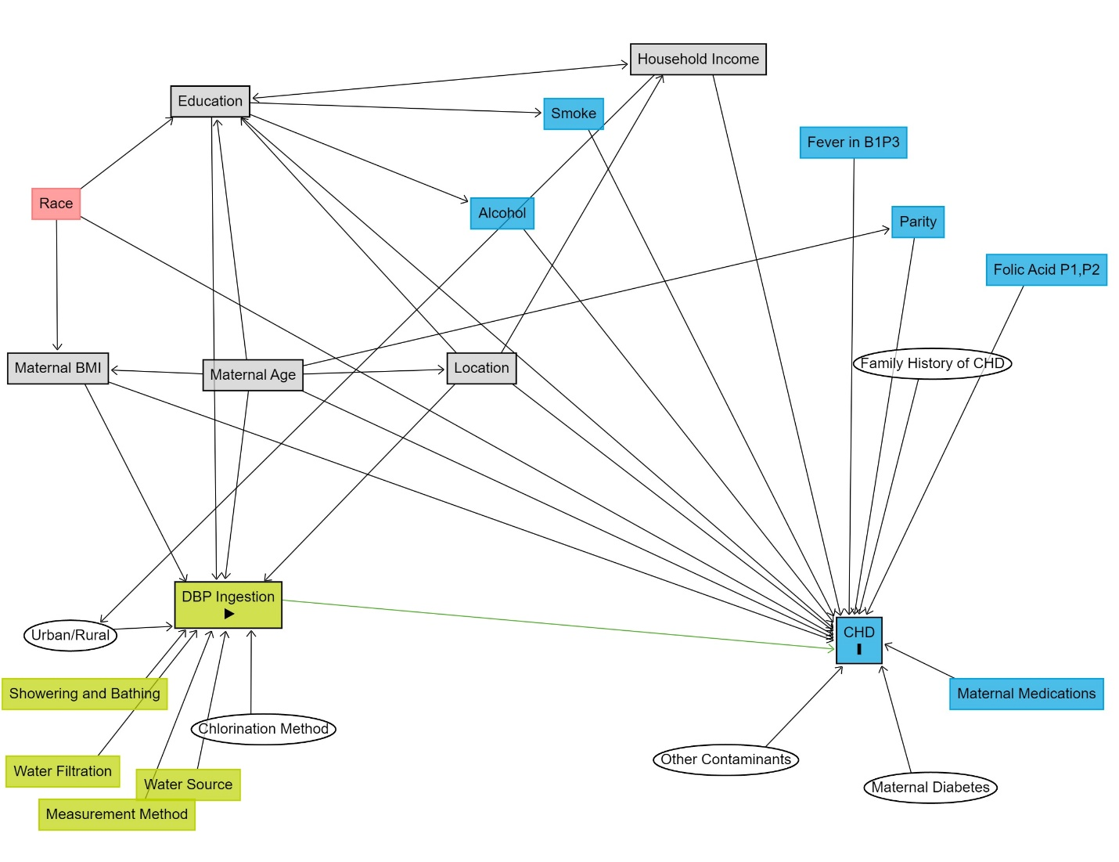
BMI=Body Mass Index; B1P3=one month before pregnancy through third month of pregnancy; CHD=Congenital Heart Defect; DBP=Disinfection by-product; P1=first month of pregnancy; P2=second month of pregnancy
DAGgitty color legend:
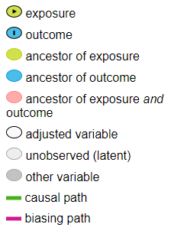
DAGitty code:

dag {
bb="-6.161,-6.613,6.148,6.288"
"Chlorination Method" [latent,pos="-3.262,4.298"]
"DBP Ingestion" [exposure,pos="-3.649,2.322"]
"Family History of CHD" [latent,pos="4.097,-1.172"]
"Fever in B1P3" [pos="3.228,-4.480"]
"Folic Acid P1,P2" [pos="5.353,-2.575"]
"Household Income" [adjusted,pos="1.522,-5.725"]
"Maternal Age" [adjusted,pos="-3.377,-1.000"]
"Maternal BMI" [adjusted,pos="-5.523,-1.100"]
"Maternal Diabetes" [latent,pos="4.076,5.171"]
"Maternal Medications" [pos="5.133,3.768"]
"Measurement Method" [pos="-4.874,5.572"]
"Other Contaminants" [latent,pos="1.825,4.756"]
"Showering and Bathing" [pos="-5.229,3.768"]
"Urban/Rural" [latent,pos="-5.386,2.895"]
"Water Filtration" [pos="-5.470,4.928"]
"Water Source" [pos="-4.089,5.128"]
Alcohol [pos="-0.635,-3.420"]
CHD [outcome,pos="3.291,2.852"]
Education [adjusted,pos="-3.848,-5.095"]
Location [adjusted,pos="-0.862,-1.101"]
Parity [pos="3.939,-3.291"]
Race [pos="-5.543,-3.563"]
Smoke [pos="0.151,-4.909"]
"Chlorination Method" -> "DBP Ingestion"
"DBP Ingestion" -> CHD
"Family History of CHD" -> CHD
"Fever in B1P3" -> CHD
"Folic Acid P1,P2" -> CHD
"Household Income" -> "Urban/Rural"
"Household Income" -> CHD
"Household Income" <-> Education
"Maternal Age" -> "DBP Ingestion"
"Maternal Age" -> "Maternal BMI"
"Maternal Age" -> CHD
"Maternal Age" -> Education
"Maternal Age" -> Location
"Maternal Age" -> Parity
"Maternal BMI" -> "DBP Ingestion"
"Maternal BMI" -> CHD
"Maternal Diabetes" -> CHD
"Maternal Medications" -> CHD
"Measurement Method" -> "DBP Ingestion"
"Other Contaminants" -> CHD
"Showering and Bathing" -> "DBP Ingestion"
"Urban/Rural" -> "DBP Ingestion"
"Water Filtration" -> "DBP Ingestion"
"Water Source" -> "DBP Ingestion"
Alcohol -> CHD
Education -> "DBP Ingestion"
Education -> Alcohol
Education -> CHD
Education -> Smoke
Location -> "DBP Ingestion"
Location -> "Household Income"
Location -> CHD
Location -> Education
Parity -> CHD
Race -> "Maternal BMI"
Race -> CHD
Race -> Education
Smoke -> CHD
}

