**SUPPORTING INFORMATION**

**Sample Collection**

Harm reduction programs, drug user unions, and public health departments were eligible to send samples. Programs applied to use the service through the website <https://streetsafe.supply> and were vetted to prevent collusion with law enforcement. Most harm reduction programs were fixed site or mobile syringe service programs. Programs were required to review an instructional video (https://vimeo.com/571816432) and sent sample collection kits, which contained:

* surgical drape to provide a clean surface and prevent contamination
* pair of nitrile gloves
* packet of 2 swabs
* non-static 10mg plastic scoop
* biodegradable bioplastic spatula
* 1 screw-top vial containing 1.5 mL acetonitrile (sealed with Parafilm)
* 2 pieces of Parafilm to reseal the vial
* Instruction and data collection card
* card with QR code for accessing results to provide to donor
* golf pencil
* pre-addressed and prepaid return FedEx Ground mailers

Sample donors were anonymous to the lab, but program identities were known. Results were returned to participants (a condition of service utilization) using a QR code linking to a website with anonymized public results. Data collection card and instructions are shown below.

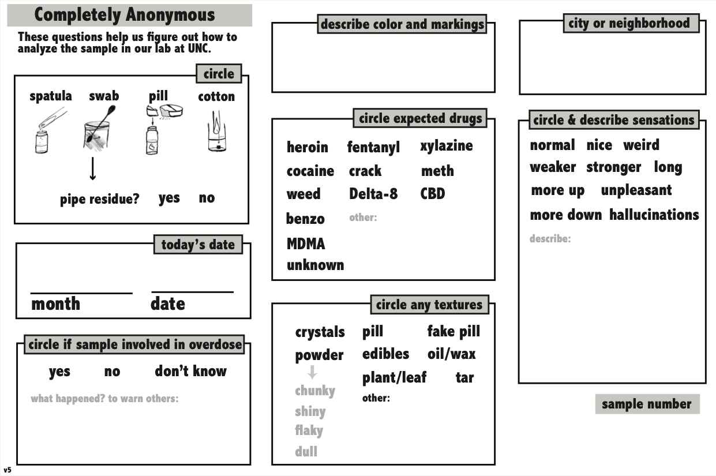

Appendix Figure 1 - Data Collection Card Side A

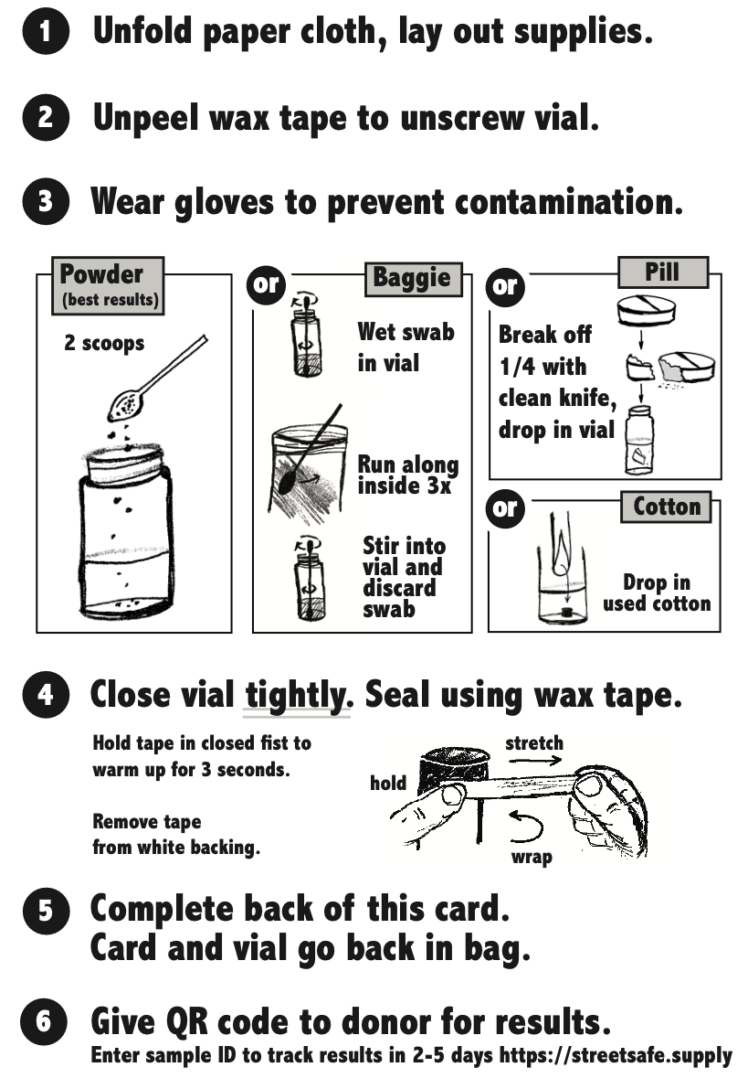

Appendix Figure 2 - Data Collection Card Side B

**Sample Collection**

In North Carolina, programs were solicited for participation in the drug checking service through outreach in collaboration with the NC Department of Health and Human Services and by word of mouth. Outside North Carolina, programs sought out the service through word of mouth referrals and from publicity through conference presentations and news media.

Programs in North Carolina were able to submit samples for free, thanks to funding from a private foundation and the NC General Assembly. Outside North Carolina, drug user unions were eligible to avail the service for free. Harm reduction programs and health departments were provided 5 free starter kits and then charged a sliding scale fee for subsequent samples ($20-$60). Harm reduction programs and health departments also used the service as confirmatory/complementary testing for point-of-care FTIR drug checking; about 60% of samples came from these FTIR sites, but the UNC lab was blinded to FTIR results. Dissolving drug samples in acetonitrile rendered them “unusable” by federal controlled substance standards, allowing them to be stored and mailed more easily. Sample originating locations (e.g., where obtained) could have been different from the location of the program collecting the sample.

**Laboratory Methods**

*a. Sample preparation*

i. Samples were sent to the laboratory in 4.0-mL vials containing the sample dissolved in 1.5mL acetonitrile. Samples were evaluated based upon participant-provided information of the expected substance. If necessary, the sample was diluted, or an appropriate extraction was performed following standard practices in forensic chemistry. Samples were provided as either: powder (approximately 10 mg); residue swabbed from the inside of an empty bag or used pipe or syringe; a fraction (approximately ¼) of a tablet; or a used cotton.

ii. Approximately 500μL of the extract was filtered into a 2.0-mL autosampler vial.

*b. Analytical method*

i. Samples were analyzed with a ThermoScientific Exactive GC with an electron ionization (EI) source. Compounds in the drug samples were identified qualitatively using a Thermo Scientific Q Exactive GC Orbitrap GC-MS System with a TriPlus RSH Autosampler. Gas chromatography separation was performed using a Thermo TraceGOLD TG-5SilMS column (30 m x 0.25 mm × 0.25 μm). One microliter injections were carried out in split mode using a 20:1 ratio mode with Helium as a carrier gas (constant flow 1.5mL/min). The GC oven temperature programming started at 100°C and was ramped to 300°C at a rate of 30°C/min, with a 9-min hold time. The total run time was 17 minutes. The inlet temperature was 280°C, while the ion source was 230°C and the MS transfer line was set at 280°C. The AGC target was set to 1×106. A 2.3-minute filament delay was used. Samples were acquired in positive mode in full SCAN mode with a range of m/z 40–500 and a resolution of 60,000.

ii. Xcalibur Qual Browser Version 4.5.445.18 (ThermoFisher, Breman, Germany) was used to analyze the data. Compound identification was performed using mass spectral libraries for fragmentation pattern analysis: SWGDRUG MS Library Version 3.10 (Scientific Working Group for the Analysis of Seized Drugs), Cayman Chemical (Ann Arbor, MI) and NIST 20 (National Institute of Standards and Technology, 2020 Version). If necessary, the retention time of compounds was compared to analytical reference standards. Standards were purchased from Cayman Chemical Company and Cerilliant Corporation (Round Rock, TX).

**APPENDIX TABLE 1. Classification count tables for presence of fentanyl in stimulants, comparing sample donor expectations with laboratory results**

|  |  |  |  |  |
| --- | --- | --- | --- | --- |
| **ALL SAMPLES** | |  |  |  |
|  |  | **Lab Confirmed Fentanyl** | |  |
| **Expected Fentanyl** |  | Yes | No |  |
| Yes | 59 | 40 | 99 |
| No | 38 | 581 | 619 |
|  |  | 97 | 621 | 718 |
|  |  |  |  |  |
|  |  |  |  |  |
|  |  |  |  |  |
| **POWDER METHAMPHETAMINE** | | | |  |
|  |  | **Lab Confirmed Fentanyl** | |  |
| **Expected Fentanyl** |  | Yes | No |  |
| Yes | 29 | 22 | 51 |
| No | 10 | 121 | 131 |
|  |  | 39 | 143 | 182 |
|  |  |  |  |  |
|  |  |  |  |  |
|  |  |  |  |  |
| **POWDER COCAINE** | | |  |  |
|  |  | **Lab Confirmed Fentanyl** | |  |
| **Expected Fentanyl** |  | Yes | No |  |
| Yes | 30 | 12 | 42 |
| No | 26 | 139 | 165 |
|  |  | 56 | 151 | 207 |
|  |  |  |  |  |
|  |  |  |  |  |
|  |  |  |  |  |
| **NO XYLAZINE** | | |  |  |
|  |  | **Lab Confirmed Fentanyl** | |  |
| **Expected Fentanyl** |  | Yes | No |  |
| Yes | 44 | 38 | 82 |
| No | 18 | 580 | 598 |
|  |  | 62 | 618 | 680 |
|  |  |  |  |  |
|  |  |  |  |  |
|  |  |  |  |  |
| **WITH XYLAZINE** | | |  |  |
|  |  | **Lab Confirmed Fentanyl** | |  |
| **Expected Fentanyl** |  | Yes | No |  |
| Yes | 15 | 2 | 17 |
| No | 20 | 1 | 21 |
|  |  | 35 | 3 | 38 |