Supplemental Figure 1. Flow chart demonstrating how the data set was created and how the categories for data stratification were created, National Addictions Vigilance Intervention and Prevention Program, 2018-2020

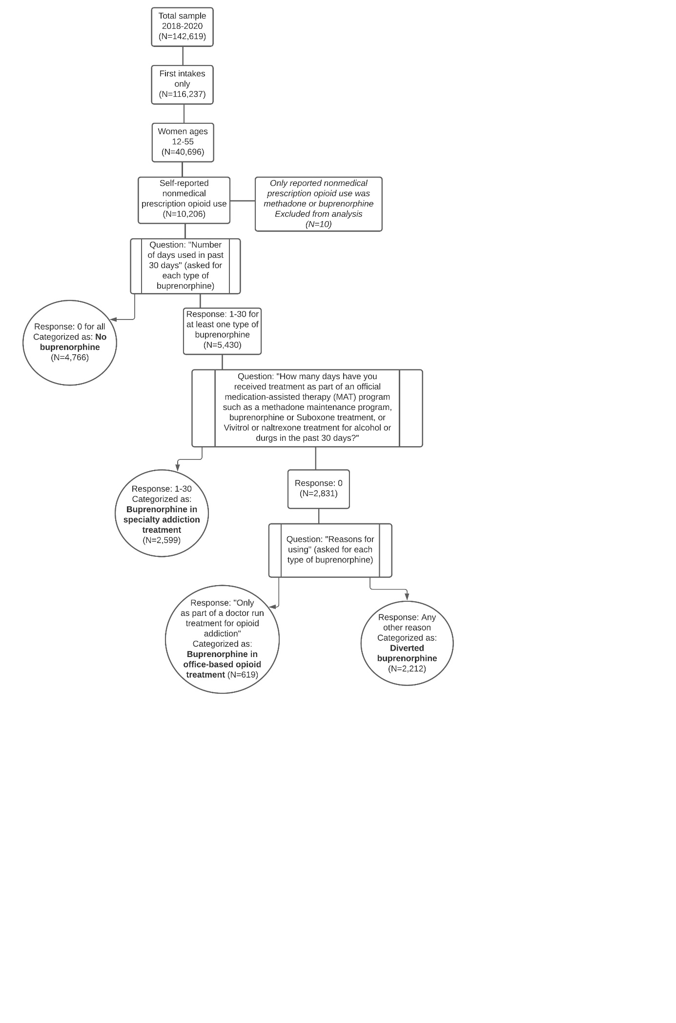

Supplemental Figure 2. Reasons for using buprenorphine to treat addiction, but not as part of a doctor-managed treatment for addiction, National Addictions Vigilance Intervention and Prevention Program, 2018-2020 (n= 1,071)